**DANY’S DINER:**

**Bonus Questions**

**Join All the Things**

1. **What is the total amount each customer spent at the restaurant?**

1. **How many days has each customer visited the restaurant?**

1. **What was the first item from the menu purchased by each customer?**

1. **What is the most purchased item on the menu and how many times was it purchased by all customers?**

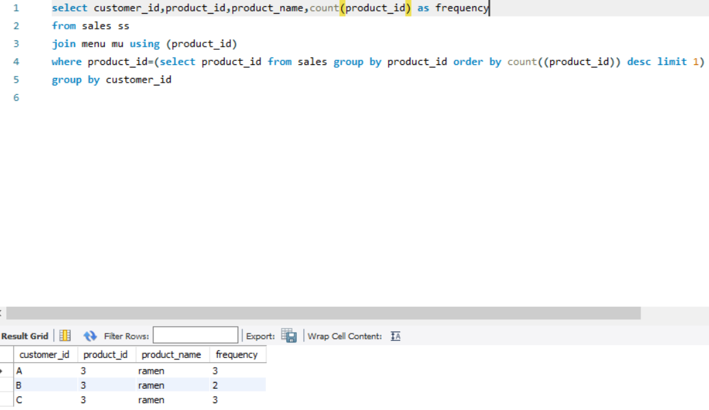

1. **Which item was the most popular for each customer?**

1. **Which item was purchased first by the customer after they became a member?**

1. **Which item was purchased just before the customer became a member?**

1. **What are the total items and amount spent for each member before they became a member?**

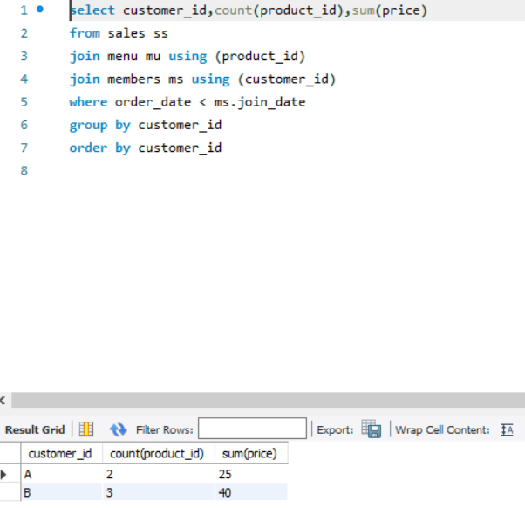

1. **If each $1 spent equates to 10 points and sushi has a 2x points multiplier - how many points would each customer have?**

1. **In the first week after a customer joins the program (including their join date) they earn 2x points on all items, not just sushi - how many points do customer A and B have at the end of January?**

